**SETUP YOUR COMPUTER FOR STUDENT MANAGEMENT SYSTEM**

1. Be sure that you have JDK and Java installed on your computer.

If not here are the links:

JAVA: https://www.java.com/en/download/

JDK: https://www.oracle.com/java/technologies/javase-jdk15-downloads.html

1. Be sure that you have SSMS and SQL 2019 installed.
2. 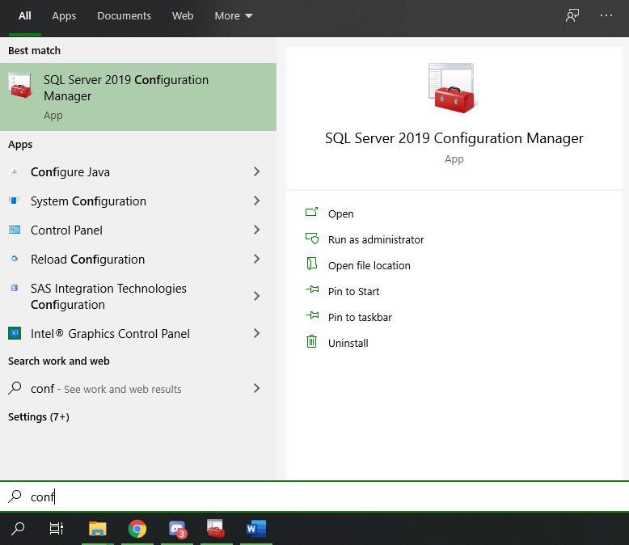Be sure that TCP IP is enabled. Follow these steps below:

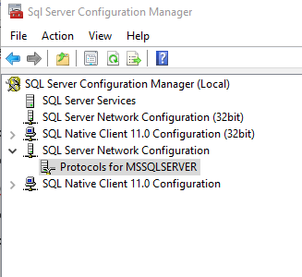

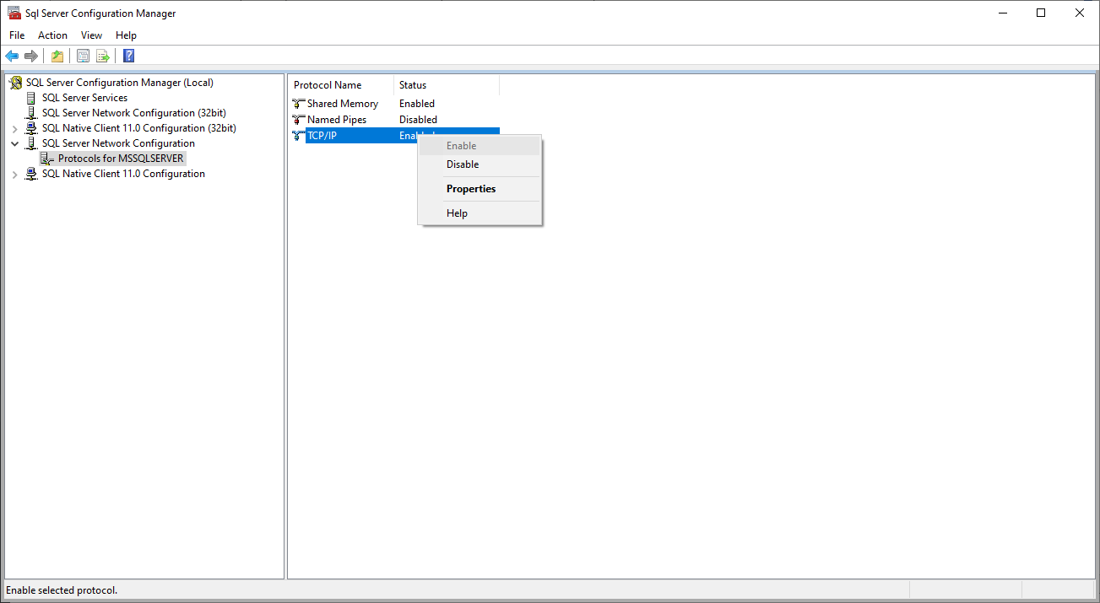

1. 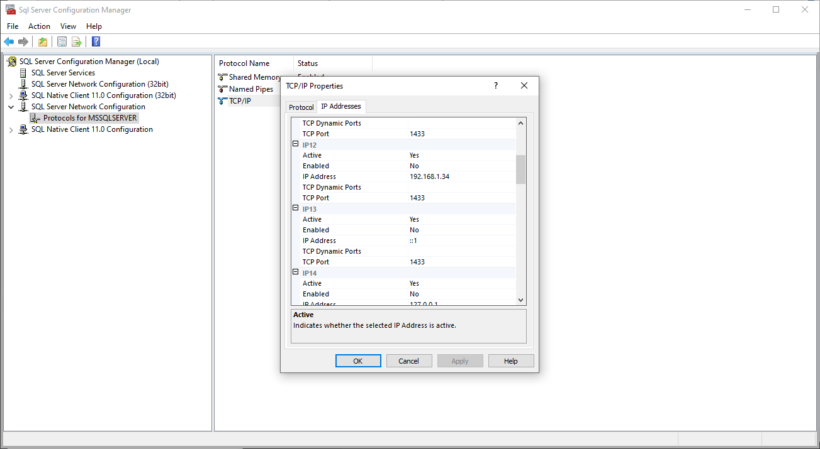Be sure that the TCP Port is set to 1433

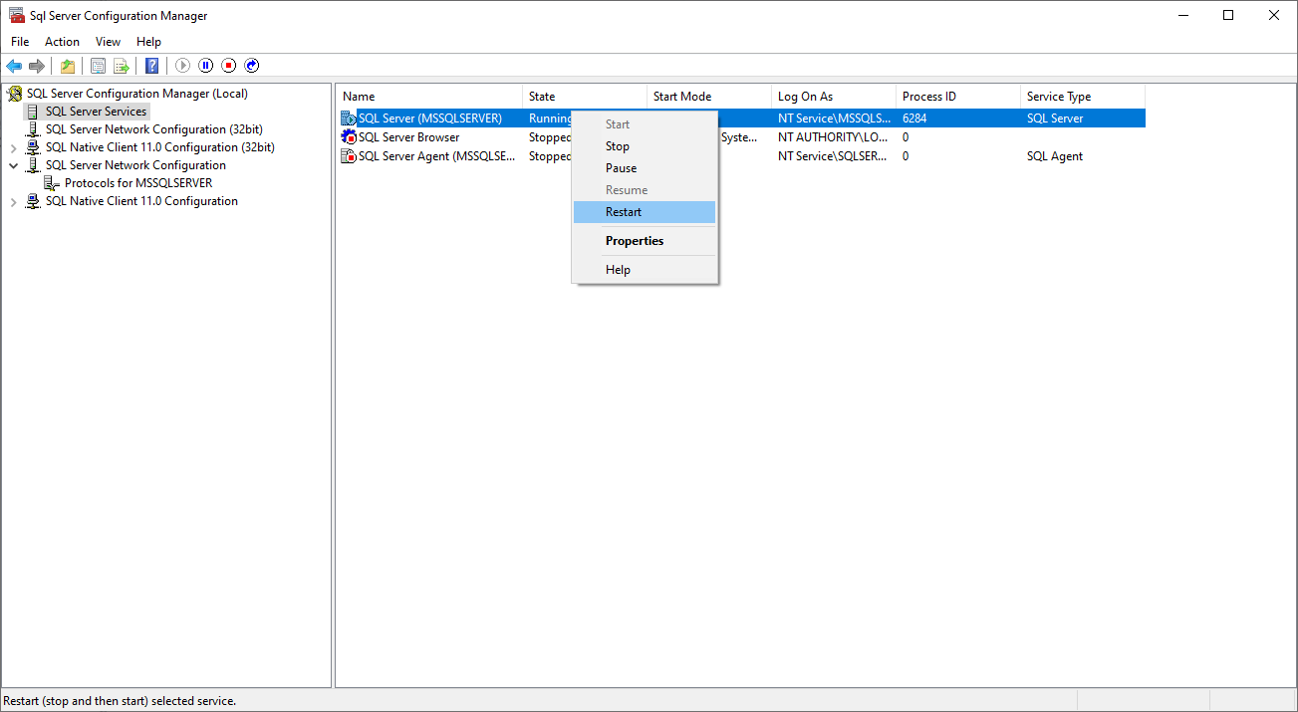

1. Now add “mssql-jdbc_auth-8.4.1.x64.dll” file to your latest JDK folder’s BIN and LIB folders (Mine is 15 yours can be 15.0.1)



C:\Program Files\Java\jdk-15\bin

C:\Program Files\Java\jdk-15\lib

If there are still errors when connecting, please email us so we can help!

[Bayram.tayyib@std.izu.edu.tr](mailto:Bayram.tayyib@std.izu.edu.tr)

[Demir.erdem@std.izu.edu.tr](mailto:Demir.erdem@std.izu.edu.tr)